5D4N BALI SHOCKING OFFER
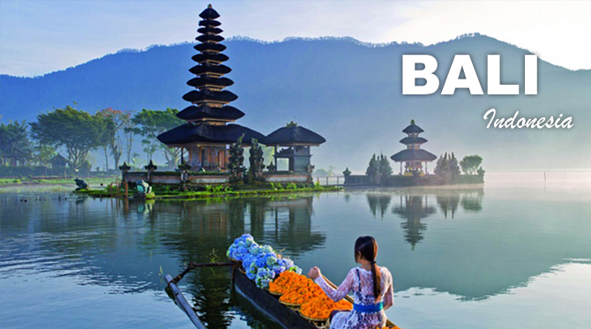
Day 1 : Airport Bali – Transfer to your hotel for overnight
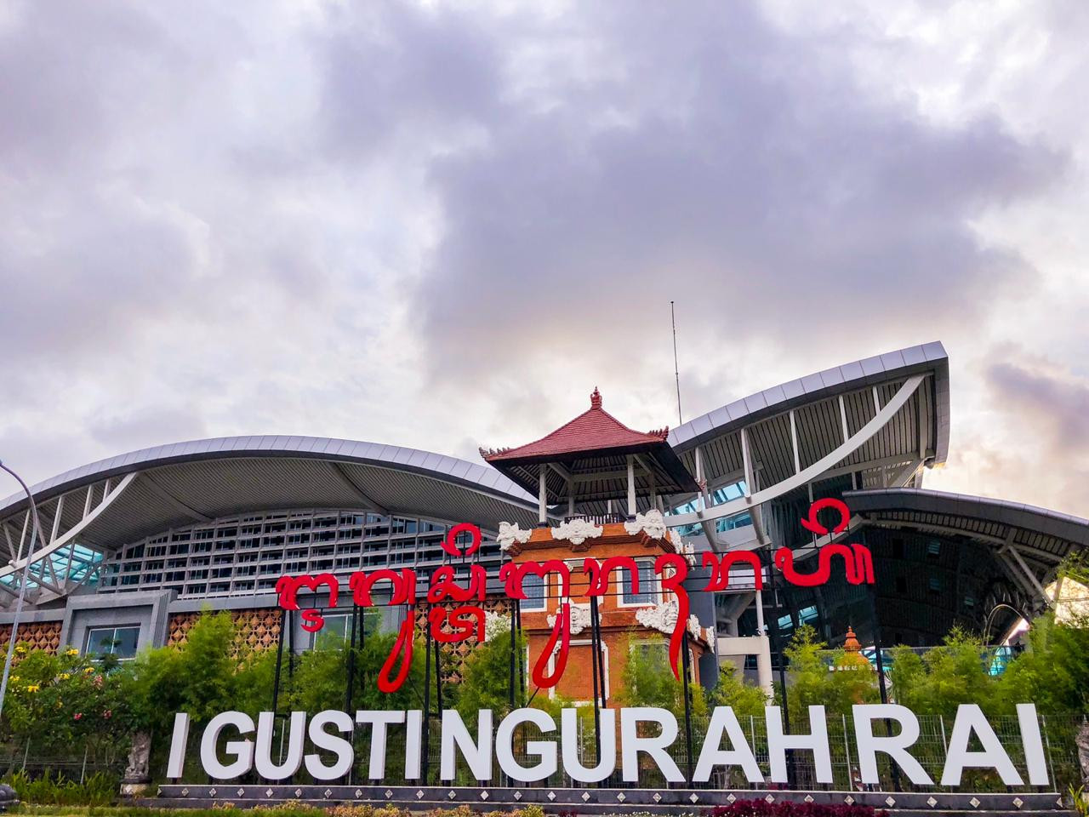
Arrive at the Ngurah Rai International Airport in Denpasar and meet and greet with our professional guide for transfer to your hotel for overnight. Rest of the day at leisure.

Day 2 : Uluwatu Temple Sunset & Kecak Dance Tour with BBQ Seafood Dinner (B,D)
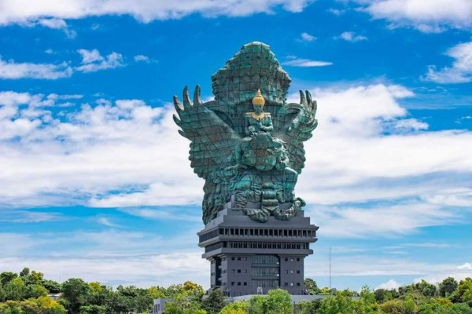
Leave from hotel in afternoon at 02.30 and Firstly we will drive to Garuda Wisnu Kencana Cultural Park ; Garuda Wisnu Kencana statue depicts Wisnu riding Garuda. In Hindu mythology, Lord Wisnu is seen as the protector of the Universe, while his trusted companion, the mighty eagle-like Garuda represents loyalty and selfless devotion. Kencana means gold, and both are adorned in crowns of gold mosaic. The Garuda is also the national emblem of Indonesia and represents freedom. Designed by renowned Balinese artist Nyoman Nuarta, the statue is made of copper and brass and features 754 modules with 25 steel segments weighing in at a hefty 900 tons, with a steel weight of 1300 tons. The statue and pedestal is 120.9 meters high with a width of 64 meters thanks to Garuda’s wingspan.
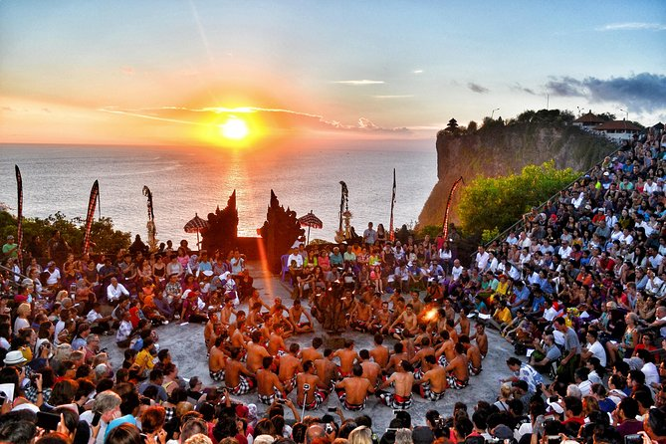
Then drive to Uluwatu to enjoy sunset of Bali from our holy Uluwatu temple located in southern part of Bali or about 45 minutes from famous Sanur Beach, this afternoon tour we’ll see a high cliff temple with sunset, after sunset , we will see the Kecak dance performance. During this dance, hundreds of men in black and white sarongs, sitting in a lotus position and raising their hands, say monotonously "ke-cak-ke-cak". Men are sitting around the platform on which the dancers, in the light of the lamp, tell the story of Rama and Sita and last Jimbaran BBQ seafood dinner (include) before back to hotel.

Day 3 : Lake Temple – Jatiluwih UNESCO Heritage Site Tour (B)
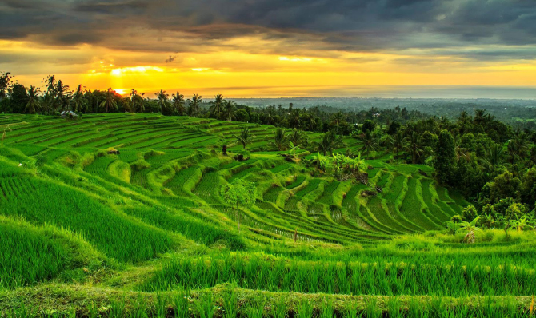
This fascinating tour highlights on landscape of Bali , with its famous of spectacular rice terrace view. We take you to visi Candikuning flower market then the 17th century Ulun Danu water temple, on the shore of lake Beratan at Bedugul , we continue our program to Jatiluwih Rice paddies where we going to have short 1 hour trekking and stop for lunch with optional cost.
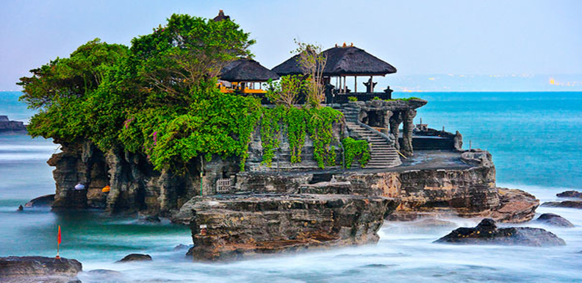
After lunch we drive to Taman Ayun Royal family temple and last Tanah Lot Temple Sunset tour before back to hotel.

Day 4 : Bali Adventure Tour with Morning Coffee at Kintamani(B)
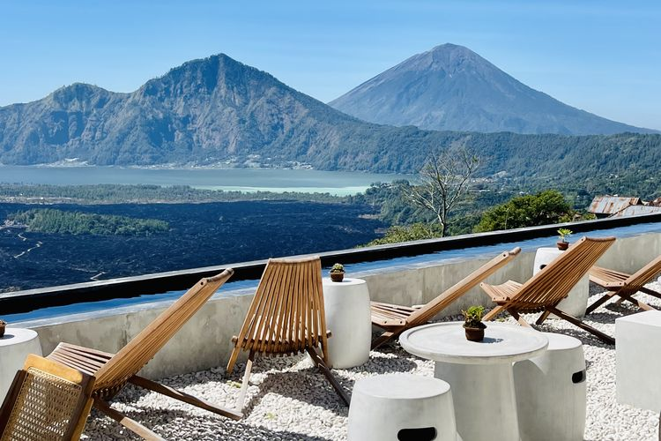

Leave early morning to Kintamani to enjoy the beauty of Mount Batur and Lake Batur with Balinese coffee and snack ,after some time we drive down to Silakarang village to have ATV ride about 2 hour. Lunch will be served at ATV Ride restaurant. Afternoon after lunch we will drive to Kedewatan village for 2 hour white water rafting at Ayung River . Back to hotel for overnight .

Activities :
2 Hour ATV Ride at Silakarang Village
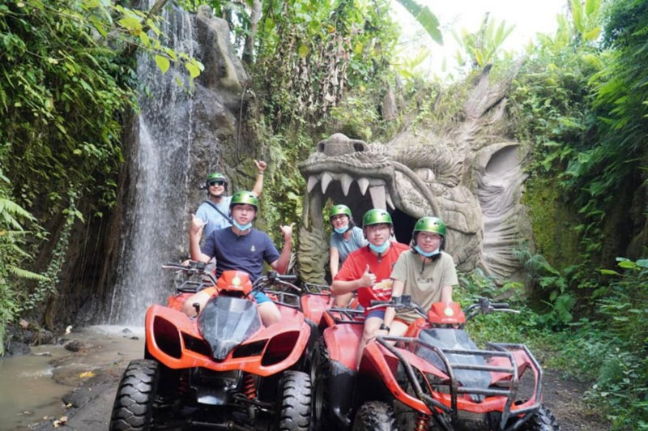

We have longest ATV trek in Bali. Located in the remote area of Gianyar Regency, 30 minutes from Ubud, We are offer great experience into the wild nature of Bali. Take you to an amazing experience riding on all-terrain vehicles (quad bike) with long and challenging track along the rice fields, jungle, rivers, and natural Bali traditional village that are not monotone. It’s safe and suitable for beginner and professional.
This trek will make your day more impressive experience to try the Bali ATV ride is treat and test your courage and adrenaline in the four Quad bikes whist enjoying the panorama of the countryside of Bali, accompanied by professional local guide, tour passed through rice paddy, villages, plantation, jungle and river and playing Mud. The trek of Bali ATV Ride need around 2 hours in 9 km longest one in Bali. Through beauty of green nature, Muddy, River, jungle, rice paddies.

White Water Rafting at Ayung River
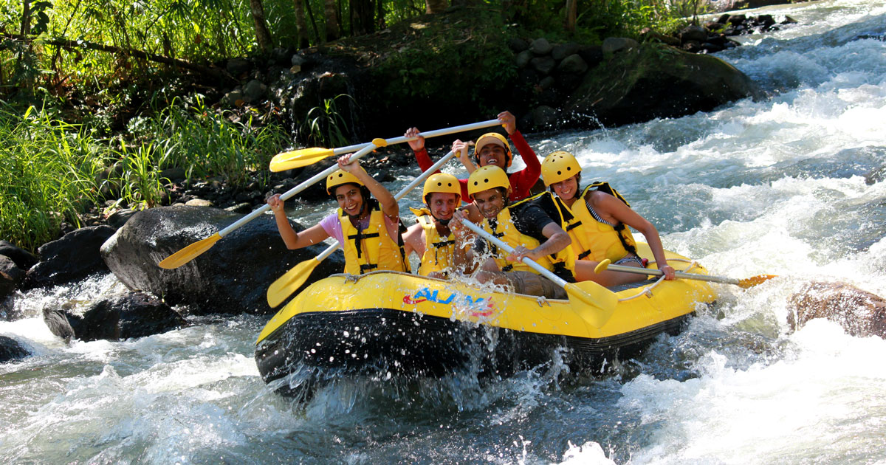

Experience Bali’s ‘must-do’ ayung river rafting adventure as you descend through lush tropical forest to the heart of the Ayung River,Ubud. After a thorough safety briefing you’ll pass through stunning scenery as you shoot thrilling Class 2-3 rapids in magnificent surroundings. The whitewater action is interspersed with Casual River cruising as you glide beneath the jungle canopy above. Discover hidden waterfalls and enjoy a swim in pristine waters and gain insight into river ecology from our expert and experienced guides.

Day 5 : Hotel – Transfer to Airport for flight HOME
Transfer to Ngurah Rai International Airport with our English speaking guide for flight home

Tour Price (NETT and not included your commission)
It may apply subject to High/ Peak season surcharge from each hotel policy
HOTELS
Day | Price per person/ Sharing Twin in US$  (Min. 2 persons) | Accommodation | Room Type
Day 01-05 | 258 | The Sun Legian 3* | Superior Room
Day 01-05 | 268 | Champlung Mas Legian 3* | Superior Room
Day 01-05 | 278 | Adi Jaya Hotel Tuban 4* | Superior Room
Day 01-05 | 288 | Kuta Beach Hotel 4* | Superior Room
Day 01-05 | 269 | Solia Bali Legian $* | Deluxe Room
Day 01-05 | 279 | Sevn Legian 4* | Superior Room
Day 01-05 | 285 | Grand Ixora Hotel Kuta 4* | Superior Room
Day 01-05 | 295 | Santika Seminyak Hotel 4* | Deluxe Room

TOUR INCLUSIONS:
Inclusions: | Non-inclusions:
- 4 Overnights accommodation including daily breakfast, hotels tax and service charges  - Sightseeing with local English speaking guides  - Entrance fees and donations  - Meals as specified (meals only, no drinks/ water)  - Mineral water on sightseeing days  - Return private air conditioned transfer with English speaking guide | - Visa  - High season surcharge for July 1 to August 31  - Drinks/water at included lunches and dinners  - Flights & airport taxes  - Hotel early check in/ Late check-out  - Overweight luggage  - Personal expenses  - Travel insurance  - Tips & gratuities  - Other services not listed in inclusive column

NOTES:
- Valid for Asian & Middle East market from January 10 to December 19,2025 (Except July 1 to August 31)
- Room for each hotel will be subject to availability
- Transfer times are approximate and subject to local conditions at the time of travel

VISAS
Please ensure your passport is valid more than 6 months from the date of return for every country you are visiting. Please also ensure there is sufficient space in your passport to allow for all immigration procedures, taking note that some South East Asian countries take up a full page for the visa sticker and need yet more space on a separate page for entry & exist stamps.

Kindly note that visa service is not included in our proposal in case your country not granted as free Visa country.

TRIP AND TRAVEL INSURANCE
The tour price does not include personal insurance. Travelers are highly recommended to purchase Trip Insurance and Travel Insurance upon commitment of the booking in case of force majeure. Trip Insurance covers the cost of your trip should you be forced to cancel your trip before you start the trip. Travel Insurance covers such costs as emergency and medical evacuation, hospital fees, property loss, etc which could possibly happen during the trip.

For Information & Enquiries :
INDONESIA IMPRESSION
Email : asia@indonesiaimpressiontour.com
CC to : info@indonesiaimpressiontour.com & reservation@indonesiaimpressiontour.com
Head Office : Andari Legian build, Jalan Jatayu II,Legian Kaja, Legian
Kuta Bali 80361 Indonesia
www.indonesiaimpressiontour.com

